**1. Load the IRIS dataset and perform univariate analysis on the sepal_length column by creating the following plots:**

**a) Histogram**

**b) Boxplot**

**c) KDE (Density) plot**

**INPUT:-**

*import* seaborn *as* sns

*import* matplotlib.pyplot *as* plt

df=sns.load_dataset('iris')

plt.figure(*figsize*=(6,4))

sns.histplot(df['sepal_length'], *bins*=10,*kde*=False,*color*='skyblue')

plt.title('Histogram of Sepal Length')

plt.xlabel('Sepal Length (cm)')

plt.ylabel('Frequency')

plt.grid(True)

plt.show()

plt.figure(*figsize*=(6,2))

sns.boxplot(*x*=df['sepal_length'],*color*='lightgreen')

plt.title('Boxplot of Sepal Lenght')

plt.xlabel('Sepal Length (cm)')

plt.grid(True)

plt.show()

plt.figure(*figsize*=(6,4))

sns.kdeplot(*x*=df['sepal_length'],*fill*=True,*color*='salmon')

plt.title('KDE Plot of Sepal Lenght')

plt.xlabel('Sepal Length (cm)')

plt.grid(True)

plt.show()

**OUTPUT:-**

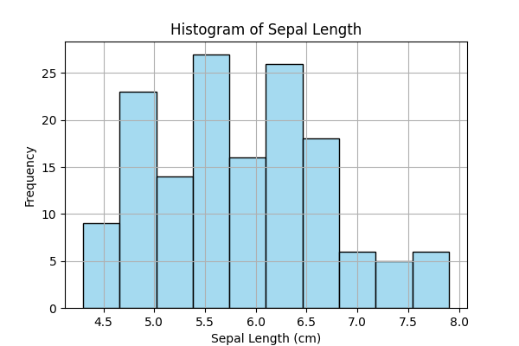

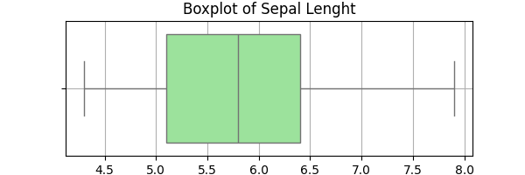

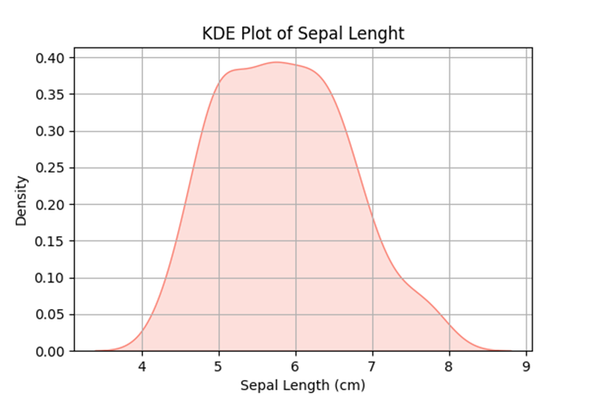

**2. Load the tips dataset and visualize how the total_bill amount varies across different days and genders using the following plots:**

**a) Boxplot**

**b) Violin Plot**

**c) Bar Plot**

**INPUT:-**

*import* pandas *as* pd

*import* matplotlib.pyplot *as* plt

*import* seaborn *as* sns

df=pd.read_csv('tip.csv')

plt.figure(*figsize*=(6,4))

sns.boxplot(*x*='day',*y*='total_bill',*hue*='sex',*data*=df)

plt.title('Boxplot: Total Bill by Day and Gender')

plt.xlabel('Day')

plt.ylabel('Total Bill($)')

plt.grid(True)

plt.show()

plt.figure(*figsize*=(6,4))

sns.violinplot(*x*='sex',*y*='total_bill',*data*=df,*palette*='pastel')

plt.title('Violin Plot: Total Bill by Gender')

plt.xlabel('Gender')

plt.ylabel('Total Bill($)')

plt.grid(True)

plt.show()

plt.figure(*figsize*=(6,4))

sns.barplot(*x*='day',*y*='total_bill',*hue*='sex',*data*=df,*ci*=None,*palette*='muted')

plt.title('Bar Plot: Average Total Bill by Day and Gender')

plt.xlabel('Day')

plt.ylabel(' Average Total Bill($)')

plt.grid(True)

plt.show()

**OUTPUT:-**

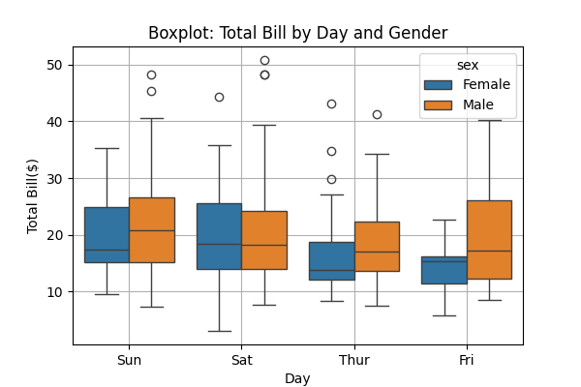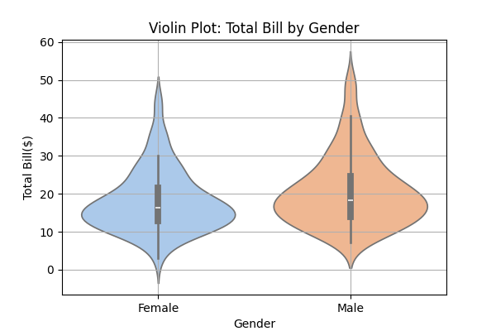

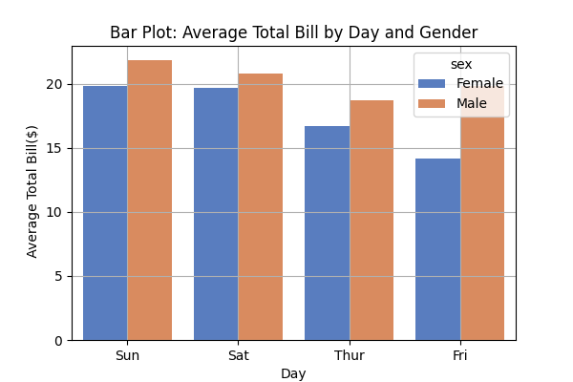

**3. Load the IRIS dataset and display the correlation between numerical features using a heatmap.**

**Interpret which features are strongly or weakly correlated based on the visualization.**

**INPUT:-**

*import* pandas *as* pd

*import* matplotlib.pyplot *as* plt

*import* seaborn *as* sns

df=pd.read_csv('Iris.csv')

corr_matrix=df.corr(*numeric_only*=True)

plt.figure(*figsize*=(6,4))

sns.heatmap(corr_matrix,*annot*=True,*cmap*='coolwarm',*linewidths*=0.5)

plt.title('Correlation Heatmap - IRIS Dataset')

plt.show()

**OUTPUT:-**

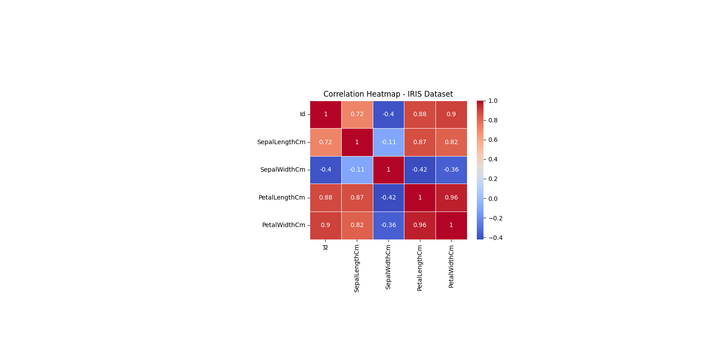

**4. Load the IRIS dataset and create a 3D scatter plot using the following axes:**

**X-axis: Sepal Length**

**Y-axis: Sepal Width**

**Z-axis; Petal Length**

**Plot the data for each species (setosa, versicolor, virginica) using different colors.**

**Add proper axis labels, title, and legend to clearly differentiate between the species.**

**INPUT:-**

*import* pandas *as* pd

*import* matplotlib.pyplot *as* plt

*from* mpl_toolkits.mplot3d *import* Axes3D

df=pd.read_csv('Iris.csv')

setosa=df[df['species']=='setosa']

versicolor=df[df['species']=='versicolor']

virginica=df[df['species']=='virginica']

fig=plt.figure(*figsize*=(8,6))

ax=fig.add_subplot(111,*projection*='3d')

ax.scatter(setosa['sepal_length'],setosa['sepal_width'],setosa['petal_length'],*color*='red',*label*='Setosa')

ax.scatter(versicolor['sepal_length'],versicolor['sepal_width'],versicolor['petal_length'],*color*='green',*label*='Versicolor')

ax.scatter(virginica['sepal_length'],virginica['sepal_width'],virginica['petal_length'],*color*='blue',*label*='Virgininca')

ax.set_xlabel('Sepal Length')

ax.set_ylabel('Sepal Width')

ax.set_zlabel('Petal Length')

ax.set_title('3D Scatter Plot = IRIS Dataset')

ax.legend()

plt.show()

**OUTPUT:-**

